70 Render - General
Rendering 2
Workflow 3
Render Engines 3
Render Output 3
Displaying and Saving Images 3
Displaying Renders 3
Saving 4
Display Options 4
Animation Playback 4
Output Options 4
Dimensions 5
Presets 6
Output Panel 6
Video Output 7
Preparing your work for video 7
Dimensions Presets 7
Pixel Aspect Ratio 7
Color Saturation 8
Rendering to fields 9
Options 10
Post Processed Effects 10
Render Layers 11
Layer List 11
Layer Panel 12
Using Render Layers 12
Post Processing Panel 12
Dithering 13
Metadata 13
Color Management 14
Scene Linear Color Space 14
Settings 15
Display 15
Render 16
Sequencer 17
Image Files 17
OpenColorIO Configuration 18
Compatibility 18
Workflows 18
Rendering Animations 18
Workflow 19
Frame Sequence Workflow 20
Options 21
Hints 21
Command Line 21
Platforms 22
Linux 22
Mac OSX 22
MS-Windows 22
Examples 23
Single Image 23
Animation 23
Render Baking 23
Options 24
Bake Mode 25
Full Render 25
Ambient Occlusion 25
Shadow 25
Normals 25
Textures 26
Displacement 26
Emission 26
Alpha 26
Mirror Color and Intensity 26
Specular Color and Intensity 26
Additional Options 27
Workflow 27
Multi-View Render 28
Introduction 29
Views Setup 30
Camera 31
Viewport 32
Stereo 3D Display 32
OpenGL Preview 33
Rendering and Image Editor 33
Image Formats 33
Final Considerations 34
Window Stereo 3D Display 34
Display Mode 34
Stereo 3D Camera 35
Convergence Mode 35
Viewport Stereo 3D 36
Multi-View and Stereo 3D Image I/O 37
Image Editor 38
Compositor 38

Rendering

Rendering is the process of creating a 2D image (or video) from your 3D scene. What that image looks like is based on four factors which the user can control:
- A Camera
- The Lighting in your scene
- The Material of each object
- Various render settings (quality, image size, layers etc)
Your computer will perform various complex calculations based on those factors in order to give you your rendered image. This process may take some time depending on the complexity of the scene and your hardware.
Once the render is complete, it is possible to do additional manipulation of the image, called Post Processing.
Finally, the output can be saved to an image or video file using one of the Output Formats.

Workflow
In general, the process for rendering is:
- Position the camera
- Light the scene
- Setup materials
- Render a test image using lower quality settings
- Change or fix anything you noticed in the render
- Repeat the above two steps until you are satisfied
- Render a high quality image, change or fix any issues and repeat until satisfied
- Save your image to a file, or render the animation to a video or image sequence.

Render Engines
The Render Engine is the set of code which controls how your materials and lighting are used, and ultimately what the rendered image looks like.
Some engines may be better at certain things than others due to the math they use or core principles around which they were written.
Bforartists includes two render engines by default:
- Bforartists Render
- Cycles
More render engines from third-party developers can also be added using Add-ons

Render Output

The render output is what the render engines have produced. The result depends of the chosen render method. You can display the result, you can post process it in various ways, and you can save the result.

Displaying and Saving Images

Rendering still images is fairly simple. Rendering Animations is a bit more complex and is covered in the next sections.
To render an image from the active camera, in the Render Panel, press the Render button. By default the 3D view is replaced with the UV/Image Editor and the render appears.

Displaying Renders
Renders are displayed in the Image Editor. You can set the way this is displayed to several different options in the Display menu:
Keep UI
The image is rendered to the Image Editor, but the UI remains the same. You will need to open the Image Editor manually to see the render result.
New Window
A new floating window opens up, displaying the render.
Image Editor
One of the existing editors is replaced with the Image Editor, showing the render.
Full Screen
The Image editor replaces the UI, showing the render.
For each of these options, pressing Esc will close the render view and return to the previous view.

Saving
Rendered images can be saved like any other image: Using Image ‣ Save As Image or by pressing F3

Display Options
When a rendered image is displayed in the Image Editor, several new menu items become available.
Slot Menu
You can save successive renders into the render buffer by selecting a new slot before rendering. If an image has been rendered to a slot, it can be viewed by selecting that slot. Empty slots appear as blank grids in the image editor. Use the J and Alt-J to cycle forwards and backwards through saved renders.
Render Layer
If you are using Render Layers, use this menu to select which layer is displayed.
Render Pass
If you are using Render Passes, use this menu to select which pass is displayed.
Display Mode
The last four buttons set how the image is displayed.
RGB
Draw image as rendered, without alpha channel.
RGBA
Replaces transparent pixels with background checkerboard, denoting the alpha channel.
Alpha Channel
Displays a gray-scale image. White areas are opaque, black areas have an alpha of 0.
Z Depth
Display the depth from the camera, from Clip Start to Clip End, as specified in the Camera settings.

Animation Playback
The ‘Play’ button in the render panel will play back your rendered animation in a new window.
You can also drop images or movie files in a running animation player. It will then restart the player with the new data.
A external player can be used instead by selecting it in the User Preferences.

Output Options

The first step in the rendering process is to determine and set the output options. This includes render size, frame rate, pixel aspect ratio, output location, and file type.

Dimensions
Resolution
X/Y
The number of pixels horizontally and vertically in the image.
Percentage slider
Reduce or increase the size of the rendered image relative to the X/Y values above. This is useful for small test renders that are the same proportions as the final image.
Aspect Ratio
Older televisions may have non-square pixels, so this can be used to control the shape of the pixels along the respective axis.
See Video Output for details on pixel aspect ratio.
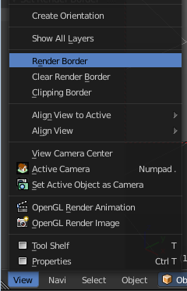
Border
You can render just a portion of the view instead of the entire frame. While in Camera View, choose Render Border in the View menu. Then in the viewport drag a rectangle around the area that you want to render. When you render the image now, then just this area gets rendered.
To remove the render border choose the menu item Clear Render Border.
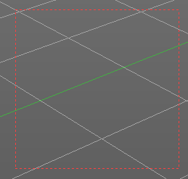

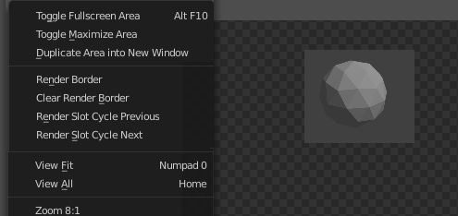
This works also in the Image Editor at the rendered result. The menu item is also in the View menu here. But here you don't have the red rectangle that shows the area to render.

Note
This disables the Save Buffers option in Performance and Full Sample option in Anti-Aliasing.

Enabling Crop will crop the rendered image to the Border size, instead of rendering a black region around it.
Frame Range
Set the Start and End frames for Rendering Animations. Step controls the number of frames to advance by for each frame in the timeline.
Frame Rate
For an Animation the frame rate is how many frames will be displayed per second.
Time Remapping
Use to remap the length of an animation.

Presets
To make life easier the topmost menu provides some common presets. You can add your own or remove one with the + and - buttons:

Output Panel
This panel provides options for setting the location of rendered frames for animations, and the quality of the saved images.
File Path
Choose the location to save rendered frames.
When rendering an animation, the frame number is appended at the end of the file name with 4 padded zeros (e.g. image0001.png). You can set a custom padding size by adding the appropriate number of # at the end of the file name (e.g. image_##.png would translate to image_01.png).
Overwrite
Overwrite existing files when rendering
Placeholders
Create empty placeholder frames while rendering
File Extensions
Adds the correct file extensions per file type to the output files
Cache Result
Saves the rendered image to your hard drive. This is helpful for heavy compositing.
Output Format
Choose the file format to save to. Based on which format is used, other options such as channels, bit-depth and compression level are available.
Hint
Primitive Render-Farm
An easy way to get multiple machines to share the rendering workload is to:
- Set up a shared directory over a network file-system.
- Disable Overwrite, enable Placeholders in the Render Output panel.
- Start as many machines as you wish rendering to that directory

Video Output

Preparing your work for video
Once you have mastered the trick of animation you will surely start to produce wonderful animations, encoded with your favorite codecs, and possibly you’ll share them on the Internet with the rest of the community.
Sooner or later you will be struck with the desire to build an animation for television, or maybe burn your own DVDs. To spare you some disappointment, here are some tips specifically targeted at Video preparation. The first and principal one is to remember the double-dashed white lines in the camera view!
If you render for PC then the whole rendered image which lies within the outer dashed rectangle will be shown. For television, some lines and some part of the lines will be lost due to the mechanics of the electron beam scanning in your TV’s cathode ray tube. You are guaranteed that what is within the inner dashed rectangle in camera view will be visible on the screen. Everything within the two rectangles may or may not be visible, depending on the given TV set that your audience watches the video on.

Dimensions Presets
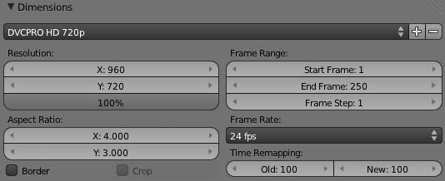
The rendering size is strictly dictated by the TV standard. There are various popular presets included, more can be added for your convenience.
Saved information is:
Resolution: | X, Y & percentage scale
Aspect ratio: | pixel aspect ratio
Frame rate: | frames per second, for animation
See also Dimensions

Pixel Aspect Ratio
Unlike regular computer monitors, some screens (typically older TV sets) do not have the square pixels making it it necessary to generate pre-distorted images which will look stretched on a computer but which will display correctly on a TV set. It is important that you use the correct pixel aspect ratio when rendering to prevent re-scaling, resulting in lowered image quality.

Color Saturation
Most video tapes and video signals are not based on the RGB model but on the YCrCb model: more precisely, the YUV in Europe (PAL), and the YIQ in the USA (NTSC), the latter being quite similar to the former. Hence some knowledge of this is necessary too.
The YCrCb model sends information as ‘Luminance’, or intensity (Y) and two ‘Crominance’ signals, red and blue (Cr and Cb). Actually a Black and White TV set shows only luminance, while color TV sets reconstruct color from Crominances (and from luminance). Construction of the YCrCb values from the RGB ones takes two steps (the constants in italics depend on the system: PAL or NTSC):
First, the Gamma correction (g varies: 2.2 for NTSC, 2.8 for PAL):
- R’ = R 1/g :*G’ = G 1/g
- B’ = B 1/g
Then, the conversion itself:
- Y = 0.299R’ + 0.587G’ + 0.114B’
- Cr = a 1 (R’ - Y) + b 1 (B’ - Y)
- Cb = a 2 (R’ - Y) + b 2 (B’ - Y)
Whereas a standard 24 bit RGB picture has 8 bits for each channel, to keep bandwidth down, and considering that the human eye is more sensitive to luminance than to chrominance, the luminance signal is sent with more bits than the two chrominance signals. This bit expansion results in a smaller dynamic of colors in video, than what you are used to on monitors. You hence have to keep in mind that not all colors can be correctly displayed.
A rule of thumb is to keep the colors as ‘grayish’ or ‘unsaturated’ as possible; this roughly means keeping the dynamics of your colors within 80% of one another. In other words, the difference between the highest RGB value and the lowest RGB value should not exceed 0.8 ([0-1] range) or 200 ([0-255] range).
This is not strict - something more than 0.8 is acceptable - but an RGB display with color contrast that ranges from 0.0 to 1.0 will appear to be very ugly (over-saturated) on video, while appearing bright and dynamic on a computer monitor.

Rendering to fields
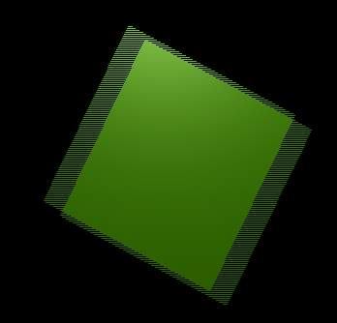
Field Rendering result.
The TV standards prescribe that there should be 25 frames per second (PAL) or 30 frames per second (NTSC). Since the phosphors of the screen do not maintain luminosity for very long, this could produce a noticeable flickering.
To minimize this, a TV does not represent frames as a computer does (‘progressive’ mode), but rather represents half-frames, or fields at a double refresh rate, hence 50 half frames per second on PAL and 60 half frames per second on NTSC. This was originally bound to the frequency of power lines in Europe (50Hz) and the US (60Hz).
In particular, fields are “interlaced” in the sense that one field presents all the even lines of the complete frame and the subsequent field the odd ones.
Since there is a non-negligible time difference between each field (1/50 or 1/60 of a second) merely rendering a frame the usual way and splitting it into two half frames does not work. A noticeable jitter of the edges of moving objects would be present.

Options
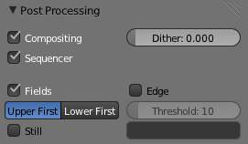
Field Rendering setup.
Fields
Enable field rendering. When the Fields button in the Render Panel is pressed (Post Processing section), Bforartists prepares each frame in two passes. On the first it renders only the even lines, then it advances in time by half a time step and renders all the odd lines. This produces odd results on a PC screen (Field Rendering result). but will show correctly on a TV set.
Upper First / Lower First
Toggles between rendering the even and odd frames first.
Still
Disables the half-frame time step between fields (x).
Note
Setting up the correct field order
Bforartists’s default setting is to produce Even fields before Odd fields; this complies with European PAL standards. Odd fields are scanned first on NTSC.
Of course, if you make the wrong selection things are even worse than if no Field rendering at all was used!
If you are really confused, a simple trick to determine the correct field order is to render a short test animation of a white square moving from left to right on a black background. Prepare one version with odd field order and another with even field order, and look at them on a television screen. The one with the right field order will look smooth and the other one horrible. Doing this simple test will save you hours of wasted rendering time...

Note
Fields and Composite Nodes
Nodes are currently not field-aware. This is partly due to the fact that in fields, too much information is missing to do good neighborhood operations (blur, vector blur etc.). The solution is to render your animation at double the frame rate without fields and do the interlacing of the footage afterwards.

Post Processed Effects

There are several effects you can enable in the Render Settings that add visual elements to rendered images, after the rendering has completed. These are not done in camera, but rather composited on top of the image.
Composited and Sequence are discussed in Output Options.
Fields are discussed in Video Output.
- Render Layers
  - Layer List
  - Layer Panel
  - Using Render Layers
- Post Processing Panel
  - Dithering
- Metadata
- Color Management
  - Scene Linear Color Space
  - Settings
  - Image Files
  - OpenColorIO Configuration
  - Compatibility

Render Layers

Reference
Editor: Properties
Context: Render Layers

Render layers allow you to render your scene in separate layers, usually with the intension of compositing them back together afterwards.
This can be useful for several purposes, such as color correcting certain elements differently, blurring the foreground as a fast manual method of creating DoF, or reducing the render quality for unimportant objects.
Using Render Layers can also save you from having to re-render your entire image each time you change something, allowing you to instead re-render only the layer(s) that you need.

Layer List
This is a list of all the Render Layers in the current scene.
Only layers which are enabled (checkbox on right is ticked) will be rendered. If the Pin icon at the bottom right of the list is enabled, only the active (highlighted) layer will be rendered.
Render Layers can be added and removed using the + and - buttons on the right, and existing layers can be renamed by double clicking on their name.

Layer Panel
The Layer Panel shows the settings of the active Render Layer from the list above.
You can select multiple layers using Shift-LMB.
Scene
The Scene Layers, showing which are currently visible and will be rendered.
Layer
The Scene Layers which are associated with the active Render Layer. Objects in those Scene Layers will be rendered in that Render Layer. When an object is in the Scene Layers but not the Render Layer, it will still cast shadows and be visible in reflections, so it is still indirectly visible.
Mask Layer
Objects on these will mask out other objects appearing behind them.
Material Override
Overrides all material settings to use the Material chosen here.
Examples of where this might be used:
- To check lighting by using a plain diffuse material on all objects
- Render a wireframe of the scene
- Create a custom render pass such as an anti-aliased matte or global coordinates.
See also
Additional options shown in this panel are different for each render engine. See these options for:
- Bforartists Render
- Cycles

Using Render Layers
Each Render Layer has an associated set of Scene Layers. Objects which are on one of the associated Scene Layers are shown in that Render Layer, as long as that Scene Layer is also visible.
Warning
Only the objects in visible Scene Layers will be rendered. So, if only Scene Layer 1 is visible and your Render Layer set specifies to render only Layers 2 and 3, nothing will be rendered.

Post Processing Panel

Compositing
Use compositing for the final image.
Sequencer
If sequencer strips are used render them instead of an image.

Dithering
Dithering is a technique for blurring pixels to prevent banding that is seen in areas of gradients, where stair-stepping appears between colors. Banding artifacts are more noticeable when gradients are longer, or less steep. Dithering was developed for graphics with low bit depths, meaning they had a limited range of possible colors.
Dithering works by taking pixel values and comparing them with a threshold and neighboring pixels then does calculations to generate the appropriate color. Dithering creates the perceived effect of a larger color palette by creating a sort of visual color mixing. For example, if you take a grid and distribute red and yellow pixels evenly across it, the image would appear to be orange.
The Dither value ranges from 0 to 2.

Metadata

The Metadata panel includes options for writing meta-data into render output.
Stamping can include the following data:
Time
Include the current scene time and render frame as HH:MM:SS.FF
Date
Include the current date and time.
RenderTime
Include the render time in the stamp image.
Frame
Include the frame number.
Scene
Include the name of the active scene.
Camera
Include the name of the active camera.
Lens
Include the name of the active camera’s lens value.
Filename
Include the filename of the .blend file.
Marker
Include the name of the last marker.
Seq. Strip
Include the name of the foreground sequence strip.
Note
Include a custom note.
Note
Only some image formats support metadata: See image formats.

Stamp Output
You can optionally stamp this into the image its self (adding text over the rendered image) which can be useful for test renders and animation previews.
Stamp Text Color
Set the color and alpha of the stamp text.
Stamp Background
Set the color and alpha of the color behind the text.
Font Size
Set the size of the text.
Hint
It can be useful to use the Note field if you’re setting up a render-farm.
Since you can script any information you like into it, such as an identifier for the render-node or the job-number.
For details on stamping arbitrary values, see: this page

Color Management

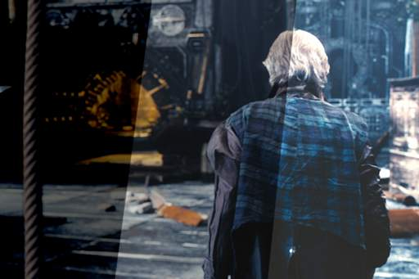
Different views and exposures of the same render
OpenColorIO is integrated into Bforartists, meaning many color spaces are supported with fine control over which color transformations are used.

Scene Linear Color Space
For correct results, different color spaces are needed for rendering, display and storage of images. Rendering and compositing is best done in scene linear color space, which corresponds more closely to nature, and makes computations more physically accurate.
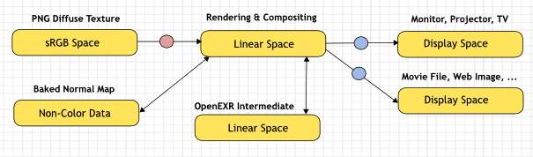
Example linear workflow
If the colors are linear, it means that if in reality we double the amount of photons, the color values are also doubled. Put another way, if we have two photos/renders each with one of two lights on, and add those images together, the result would be the same as a render/photo with both lights on. It follows that such a radiometrically linear space is best for photorealistic rendering and compositing.
However these values do not directly correspond to human perception or the way display devices work, and image files are often stored in different color spaces, so we have to take care to do the right conversion into and out of this linear color space.

Settings
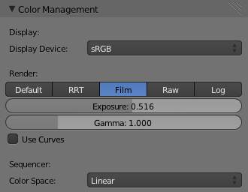
Scene settings for color management
These settings are found in the scene context of the properties editor, under the Color Management panel.

Display
Correct display of renders requires a conversion to the display device color space, which can be configured here. A computer monitor works differently from a digital cinema project or HDTV. The scene properties have these settings:
Display Device
The device that the image is being viewed on.
Most computer monitors are configured for the sRGB color space, and so when working on a computer usually this option should just be left to the default. It would typically be changed when viewing the image on another display device connected to the computer, or when writing out image files intended to be displayed on another device.
Rec709 is commonly used for HDTVs, while XYZ and DCI-P3 are common for digital projectors.
Color management can be disabled by setting the device to None.
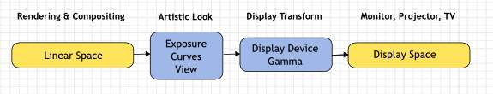
Conversion from linear to display device space

Render
There is also an artistic choice to be made for renders. Partially that’s because display devices can’t display the full spectrum of colors and only have limited brightness, so we can squeeze the colors to fit in the gamut of the device. Besides that it can also be useful to give the renders a particular look, e.g. as if they have been printed on real film.
Another common use case is when you want to inspect renders, to see details in dark shadows or bright highlights, or identify render errors. Such settings would be only used temporarily and not get used for final renders.
View
These are different ways to view the image on the same display device.
Default
Does no extra conversion besides the conversion for the display device.
RRT
Uses the ACES Reference Rendering Transform, to simulate a film-like look.
Film
This option is another film-like look.
Raw and Log
Intended for inspecting the image but not for final export. Raw gives the image without any color space conversion, while Log gives a more “flat” view of the image without very dark or light areas.
Exposure
Used to control the image brightness (in stops) applied before color space conversion.
Gamma
Extra gamma correction applied after color space conversion. Note that the default sRGB or Rec709 color space conversions already include a gamma correction of approximately 2.2 (except the Raw and Log views), so this would be applied in addition to that.
Look
Choose an artistic effect from set of measured film response data which roughly emulates the look of certain film types. Applied before color space conversion.
Use Curves
Adjust RGB Curves to control image colors before color space conversion. Read more about using the Curve Widget.

Sequencer
Color Space
The color space that the sequencer operates in. By default the sequencer operates in sRGB space, but it can also be set to work in Linear space like the Compositing nodes, or another color space. Different color spaces will give different results for color correction, cross fades, and other operations.

Image Files
The other place to keep color management in mind is when loading and saving image files. File formats such as PNG or JPEG will typically store colors in a color space ready for display, not in a linear space. When they are, for example, used as textures in renders, they need to be converted to linear first, and when saving renders for display on the web, they also need to be converted to a display space. Other file formats like OpenEXR store linear color spaces and as such are useful as intermediate files in production.
When working with image files, the default color space is usually the right one. If this is not the case, the color space of the image file can be configured in the image settings. A common situation where manual changes are needed is when working with or baking normal maps or displacement maps, for example. Such maps do not actually store colors, just data encoded as colors. In such cases they should be marked as Non-Color Data.
Image data-blocks will always store float buffers in memory in the scene linear color space, while a byte buffer in memory and files on disk are stored in the color space specified with this setting:
Color Space
The color space of the image on disk. This depends on the file format, for example PNG or JPEG images are often stored in sRGB, while OpenEXR images are stored in a linear color space. Some images such as normal, bump or stencil maps do not strictly contain ‘colors’, and on such values no color space conversion should ever be applied. For such images the color space should be set to None.
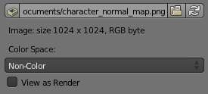
Image settings for color management
By default only renders are displayed and saved with the render view transformations applied. These are the Render Result and Viewer image data-blocks, and the files saved directly to disk with the Render Animation operator. However when loading a render saved to an intermediate OpenEXR file, Bforartists can’t detect automatically that this is a render (it could be e.g. an image texture or displacement map). We need to specify that this is a render and that we want the transformations applied, with these two settings:
View as Render
Display the image data-block (not only renders) with view transform, exposure, gamma, RGB curves applied. Useful for viewing rendered frames in linear OpenEXR files the same as when rendering them directly.
Save as Render
Option in the image save operator to apply the view transform, exposure, gamma, RGB curves. This is useful for saving linear OpenEXR to e.g. PNG or JPEG files in display space.

OpenColorIO Configuration
Bforartists comes with a standard OpenColorIO configuration that contains a number of useful display devices and view transforms. The reference linear color space used is the linear color space with Rec. 709 chromaticities and D65 white point.
However OpenColorIO was also designed to give a consistent user experience across multiple applications, and for this a single shared configuration file can be used. Bforartists will use the standard OCIO environment variable to read an OpenColorIO configuration other than the default Bforartists one. More information about how to set up such a workflow can be found on the OpenColorIO website.
We currently use the following color space roles:
scene_linear
color space used for rendering, compositing, and storing all float precision images in memory.
default_sequencer
default color space for sequencer, scene_linear if not specified
default_byte
default color space for byte precision images and files, texture_paint if not specified.
default_float
default color space for float precision images and files, scene_linear if not specified.
The standard Bforartists configuration also includes some support for ACES (code and documentation), even though we have a different linear color space. It’s possible to load and save EXR files with the Linear ACES color space, and the RRT view transform can be used to view images with their standard display transform. However the ACES gamut is larger than the Rec. 709 gamut, so for best results an ACES specific configuration file should be used. OpenColorIO provides an ACES configuration, though it may need a few more tweaks to be usable in production.

Compatibility
Compatibility with existing files should mostly be preserved. Files that had color management enabled should be entirely compatible, while older files with the color management option disabled are mostly compatible but different for vertex colors and viewport colors.

Workflows

The workflow to render depends of the chosen render and what you want to render. A still or an animation for example.

Rendering Animations

While rendering stills will allow you to view and save the image from the render buffer when it’s complete, animations are a series of images, or frames, and are automatically saved directly out to disk after being rendered.
After rendering the frames, you may need to edit the clips, or first use the Compositor to do green-screen masking, matting, color correction, DOF, and so on to the images. That result is then fed to the Sequencer where the strips are cut and mixed and a final overlay is done.
Finally you can render out from the Sequencer and compress the frames into a playable movie clip.

Workflow
Generally, you do a lot of intermediate renders of different frames in your animation to check for timing, lighting, placement, materials, and so on. At some point, you are ready to make a final render of the complete animation for publication.
There are two approaches you can use when making a movie, or animation, with or without sound. The approach you should use depends on the amount of CPU time you will need to render the movie. You can render a “typical” frame at the desired resolution, and then multiply by the number of frames that will ultimately go into the movie, to arrive at an total render time.
If the total render time is an hour or more, you want to use the “Frame Sequence” approach. For example, if you are rendering a one-minute video clip for film, there will be (60 seconds per minute) * (24 frames per second) or 1440 frames per minute. If each frame takes 30 seconds to render, then you will be able to render two frames per minute, or need 720 minutes (12 hours) of render time.
Rendering takes all available CPU time; you should render overnight, when the computer is not needed, or set Bforartists to a low priority while rendering, and work on other things (be careful with the RAM space!).
The Direct Approach - highly not recommended and not a standard practice - is where you set your output format to an AVI or MOV format, and click ANIM to render your scene directly out to a movie file. Bforartists creates one file that holds all the frames of your animation. You can then use Bforartists’s VSE to add an audio track to the animation and render out to an MPEG format to complete your movie.
The Frame Sequence is a much more stable approach, where you set your output format to a still format (such as JPG, PNG or MultiLayer), and click ANIM to render your scene out to a set of images, where each image is the frame in the sequence.
Bforartists creates a file for each frame of the animation. You can then use Bforartists’s compositor to perform any frame manipulation (post processing). You can then use Bforartists’s VSE to load that final image sequence, add an audio track to the animation, and render out to an MPEG format to complete your movie. The Frame Sequence approach is a little more complicated and takes more disk space, but gives you more flexibility.
Here are some guidelines to help you choose an approach.
Direct Approach
- short segments with total render time < 1 hour
- stable power supply
- computer not needed for other uses
Frame Sequence Approach
- total render time > 1 hour
- post-production work needed
  - Color/lighting adjustment
  - Green screen / matte replacement
  - Layering/compositing
  - Multiple formats and sizes of ultimate product
- intermediate frames/adjustments needed for compression/codec
- precise timing (e.g. lip-sync to audio track) needed in parts
- may need to interrupt rendering to use the computer, and want to be able to resume rendering where you left off.

Frame Sequence Workflow
- First prepare your animation.
- In the Dimensions panel, choose the render size, Pixel Aspect Ratio, and the Range of Frames to use, as well as the frame rate, which should already be set.
- In the Output panel set up your animation to be rendered out as images, generally using a format that does not compromise any quality (I prefer PNG or MultiLayer because of their loss-less nature).
- Choose the output path and file type in the Output panel as well, for example //render/my-anim-.
- Confirm the range of your animation frame Start and End.
- Save your .blend file.
- Press the big Animation button. Do a long task [like sleeping, playing a video game, or cleaning your driveway] while you wait for your computer to finish rendering the frames.
- Once the animation is finished, use your OS file explorer to navigate into the output folder (“render in this example). You will see lots of images (.png or .exr, etc... depending on the format you chose to render) that have a sequence number attached to them ranging from 0000 to a max of 9999. These are your single frames.
- In Bforartists, now go into the video sequence editor.
- Choose Add Image from the add menu. Select all the frames from your output folder that you want to include in your animation (Press A to Select All easily). They will be added as a strip to the sequence editor.
- Now you can edit the strip and add effects or simply leave it like it is. You can add other strips, like an audio strip.
- Scrub through the animation, checking that you have included all the frames.
- In the Scene Render buttons, in the Post Processing panel, activate Sequencer.
- In the Format panel, choose the container and codec you want (e.g. MPEG H.264) and configure it. The video codecs are described on the previous page: Output Options.
- Click the ANIMATION render button and Bforartists will render out the sequence editor output into your movie.
Why go through all this hassle? Well, first of all, if you render out single frames you can stop the render at any time by pressing Esc in the render window. You will not lose the frames you have already rendered, since they have been written out to individual files. You can always adjust the range you want to continue from where you left off.
You can edit the frames afterwards and post-process them. You can add neat effects in the sequence editor. You can render the same sequence into different resolutions (640x480, 320x240, etc) and use different codecs (to get different file sizes and quality) with almost no effort whatsoever.

Options
Post Processing Panel
Sequencer
Renders the output of the sequence editor, instead of the view from the 3D scene’s active camera. If the sequence contains scene strips, these will also be rendered as part of the pipeline. If Do Composite is also enabled, the Scene strip will be the output of the Compositor.
Compositing
Renders the output from the Compositing noodle, and then pumps all images through the Composite node map, displaying the image fed to the Composite Output node.

Hints
You accidentally turned off you’re PC right in the middle of rendering my movie!
Unless your animation renders in a few minutes, it’s best to render the animation as separate image files. Instead of rendering directly to a compressed movie file, use a loss-less format (PNG for example).
This allows you an easy recovery if there is a problem and you have to re-start the rendering, since the frames you have already rendered will still be in the output directory.
Just disable the Overwrite option to start rendering where you left off.
You can then make a movie out of the separate frames with Bforartists’s sequence editor or using 3rd party encoding software.
Animation Preview
It can be useful to render a subset of the animated sequence, since only part of an animation may have an error.
Using an image format for output, you can use the Frame Step option to render every N’th frame. Then disable Overwrite and re-render with Frame Step set to 1.

Command Line

In some situations we want to increase the render speed, access Bforartists remotely to render something or build scripts that use the command line.
One advantage of using the command line is that we don’t need the X server (in the case of Linux) and consequently we can render remotely by SSH or telnet.
To see a list of available flags (for example to specify which scene to render, the end frame number, etc...), simply run:
Bforartists --help
Note
Arguments are executed in the order they are given!
The following command won’t work, since the output and extension is set after Bforartists is told to render:
Bforartists -b file.blend -a -x 1 -o //render
The following command will behave as expected.
Bforartists -b file.blend -x 1 -o //render -a
Always position -f or -a as the last arguments.

Platforms
How to actually execute Bforartists from the command line depends on the platform and where you have installed Bforartists. Here are basic instructions for the different platforms.

Linux
Open a terminal, then go to the directory where Bforartists is installed, and run the Bforartists command like this.
cd <Bforartists installation directory>
./Bforartists
If you have Bforartists installed in your PATH (usually when Bforartists is installed through a distribution package), you can simply run:
Bforartists

Mac OSX
Open the terminal application, go to the directory where Bforartists is installed, and run the executable within the app bundle, with commands like this:
cd /Applications/Bforartists
./Bforartists.app/Contents/MacOS/Bforartists
If you need to do this often, you can make an alias so that typing just Bforartists in the terminal works. For that you can run a command like this in the terminal (with the appropriate path).
echo "alias Bforartists=/Applications/Bforartists/Bforartists.app/Contents/MacOS/Bforartists" >> ~/.profile
If you then open a new terminal, the following command will work:
Bforartists

MS-Windows
Open the Command Prompt, go to the directory where Bforartists is installed, and then run the Bforartists command.
cd c:\<Bforartists installation directory>
Bforartists
You can also add the Bforartists folder to your system PATH so that do you do not have to change to it each time.

Examples
Here are some common examples of command line rendering:

Single Image
Bforartists -b file.blend -f 10
-b
Render in the background (without UI).
file.blend
Path to the blend file to render.
-f 10
Render only the 10th frame.
Bforartists -b file.blend -o /project/renders/frame_##### -F EXR -f -2
-o /project/renders/frame_#####
Path of where to save the rendered image, using 5 padded zeros for the frame number.
-F EXR
Override the image format specified in the blend file and save to an OpenEXR image.
-f -2
Render only the second last frame.
Warning
Arguments are case sensitive! -F and -f are not the same.

Animation
Bforartists -b file.blend -a
-a
Render the whole animation using all the settings saved in the blend file.
Bforartists -b file.blend -E Bforartists_RENDER -s 10 -e 500 -t 2 -a
-E Bforartists_RENDER
Use the “Bforartists Render” engine. For a list of available renderers, run Bforartists -E help.
-s 10 -e 500
Set the start frame to 10 and the end frame to 500.
-t 2
Use only two threads.

Render Baking

Baking, in general, is the act of pre-computing something in order to speed up some other process later down the line. Rendering from scratch takes a lot of time depending on the options you choose. Therefore, Bforartists allows you to “bake” some parts of the render ahead of time, for select objects. Then, when you press Render, the entire scene is rendered much faster, since the colors of those objects do not have to be recomputed.
Render baking creates 2D bitmap images of a mesh object’s rendered surface. These images can be re-mapped onto the object using the object’s UV coordinates. Baking is done for each individual mesh, and can only be done if that mesh has been UV-unwrapped. While it takes time to set up and perform, it saves render time. If you are rendering a long animation, the time spent baking can be much less than time spent rendering out each frame of a long animation.
Use Render Bake in intensive light/shadow solutions, such as AO or soft shadows from area lights. If you bake AO for the main objects, you will not have to enable it for the full render, saving render time.
Use Full Render or Textures to create an image texture; baked procedural textures can be used as a starting point for further texture painting. Use Normals to make a low-resolution mesh look like a high-resolution mesh. To do that, UV-unwrap a high-resolution, finely sculpted mesh and bake its normals. Save that normal map, and Mapping (texture settings) the UV of a similarly unwrapped low-resolution mesh. The low-resolution mesh will look just like the high-resolution, but will have much fewer faces/polygons.
Advantages
- Can significantly reduce render times
- Texture painting made easier
- Reduced polygon count
- Repeated renders are made faster, multiplying the time savings
Disadvantages
- Object must be UV-unwrapped.
- If shadows are baked, lights and object cannot move with respect to each other.
- Large textures (eg 4096x4096) can be memory intensive, and be just as slow as the rendered solution.
- Human (labor) time must be spent unwrapping and baking and saving files and applying the textures to a channel.

Options
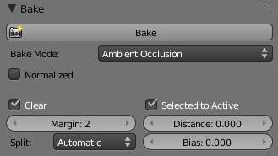
Ambient Occlusion

Bake Mode

Full Render
Bakes all materials, textures, and lighting except specularity and SSS.

Ambient Occlusion
Bakes ambient occlusion as specified in the World panels. Ignores all lights in the scene.
Normalized
Normalize without using material’s settings.

Shadow
Bakes shadows and lighting.
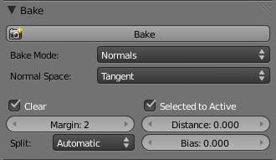
Normals
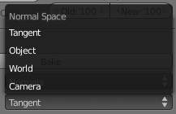
Normal Space

Normals
Bakes tangent and camera-space normals (amongst many others) to an RGB image.
Normal Space
Normals can be baked in different spaces:
Camera space
Default method.
World space
Normals in world coordinates, dependent on object transformation and deformation.
Object space
Normals in object coordinates, independent of object transformation, but dependent on deformation.
Tangent space
Normals in tangent space coordinates, independent of object transformation and deformation. This is the new default, and the right choice in most cases, since then the normal map can be used for animated objects too.
For materials the same spaces can be chosen as well, in the image texture options, next to the existing Normal Map setting. For correct results, the setting here should match the setting used for baking.

Textures
Bakes colors of materials and textures only, without shading.
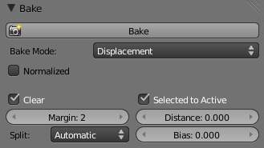
Displacement

Displacement
Similar to baking normal maps, displacement maps can also be baked from a high-res object to an unwrapped low-res object, using the Selected to Active option.
Normalized
Normalize to the distance.
When using this in conjunction with a subsurf and displacement modifier within Bforartists, it’s necessary to temporarily add a heavy subsurf modifier to the ‘low res’ model before baking. This means that if you then use a displacement modifier on top of the subsurf, the displacement will be correct, since it’s stored as a relative difference to the subsurfed geometry, rather than the original base mesh (which can get distorted significantly by a subsurf). The higher the render level subsurf while baking, the more accurate the displacements will be. This technique may also be useful when saving the displacement map out for use in external renderers.

Emission
Bakes Emit, or the Glow color of a material.

Alpha
Bakes Alpha values, or transparency of a material.

Mirror Color and Intensity
Bakes Mirror color or intensity values.

Specular Color and Intensity
Bakes specular color or specular intensity values.
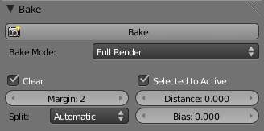
Full Render

Additional Options
Clear
If selected, clears the image to selected background color (default is black) before baking render.
Margin
Baked result is extended this many pixels beyond the border of each UV “island,” to soften seams in the texture.
Split
Fixed
Slit quads predictably (0,1,2) (0,2,3).
Fixed alternate
Slit quads predictably (1,2,3) (1,3,0).
Automatic
Split quads to give the least distortion while baking.
Select to Active
Enable information from other objects to be baked onto the active object.
Distance
Controls how far a point on another object can be away from the point on the active object. Only needed for Selected to Active. A typical use case is to make a detailed, high poly object, and then bake it’s normals onto an object with a low polygon count. The resulting normal map can then be applied to make the low poly object look more detailed.
Bias
Bias towards further away from the object (in Bforartists units)
Note
Mesh Must be Visible in Render
If a mesh is not visible in regular render, for example because it is disabled for rendering in the Outliner or has the DupliVerts setting enabled, it cannot be baked to.

Workflow
- In a 3D View window, select a mesh and enter UV/Face Select mode
- Unwrap the mesh object
- In a UV/Image Editor window, either create a new image or open an existing one. If your 3D view is in textured display mode, you should now see the image mapped to your mesh. Ensure that all faces are selected.
- In the Bake panel at the bottom of the Render menu, bake your desired type of image (Full Render etcetera.)
- When rendering is complete, Bforartists replaces the image with the Baked image.
- Save the image.
- Apply the image to the mesh as a UV texture. For displacement and normal maps, refer to Bump and Normal Maps. For full and texture bakes, refer to Textures.
- Refine the image using the process described below, or embellish with Texture Paint or an external image editor.

Multi-View Render

For this 5-minute guide we will take an existent .blend file that was made for monoscopic rendering and transform it in stereo-3d ready.
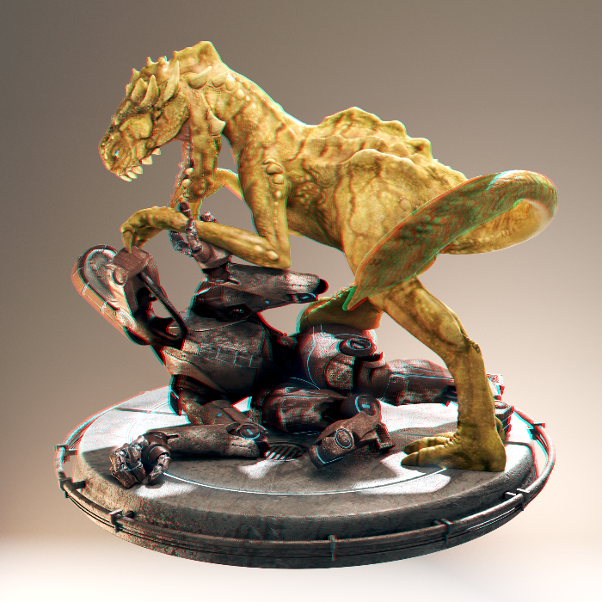
Creature Factory 2 by Andy Goralczyk Rendered in Stereo 3D (anaglyph)
Note
Multi-View drawing requires capable graphics card and drivers with Triple Buffer support. If the Automatic mode doesn’t work, set the Window Draw Method in the System User Preferences.

Introduction
Start opening up your project file, in this case turntable.blend from the Creature Factory 2 Open Movie Workshop series from the Bforartists Institute by Andy Goralczyk.
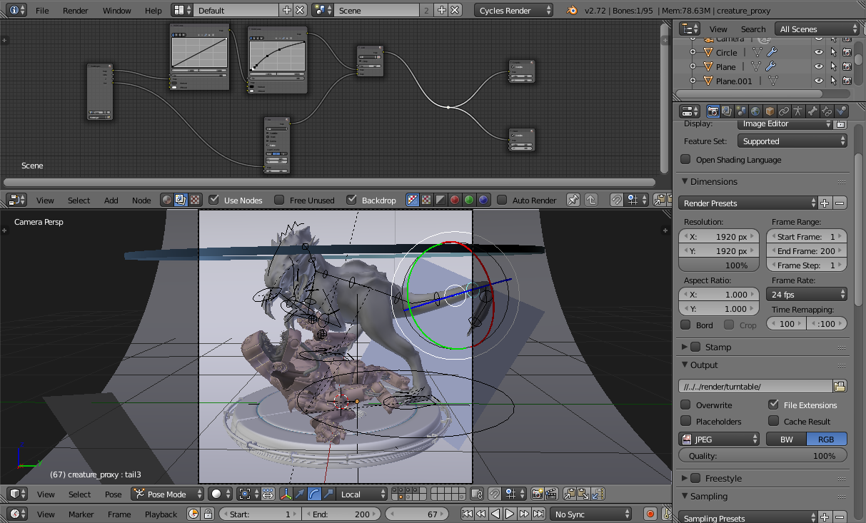
Turn Table Creature Factory 2

Views Setup
Go to the Render Layers panel and enable Views for this scene.
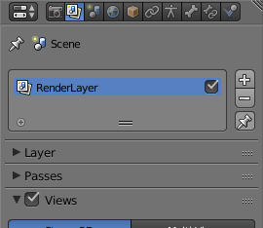
Scene Render Views
Note
When you turn on Views in the scene you get 3d preview in the viewport, as well as multiple panels that are now accessible all over the user interface.

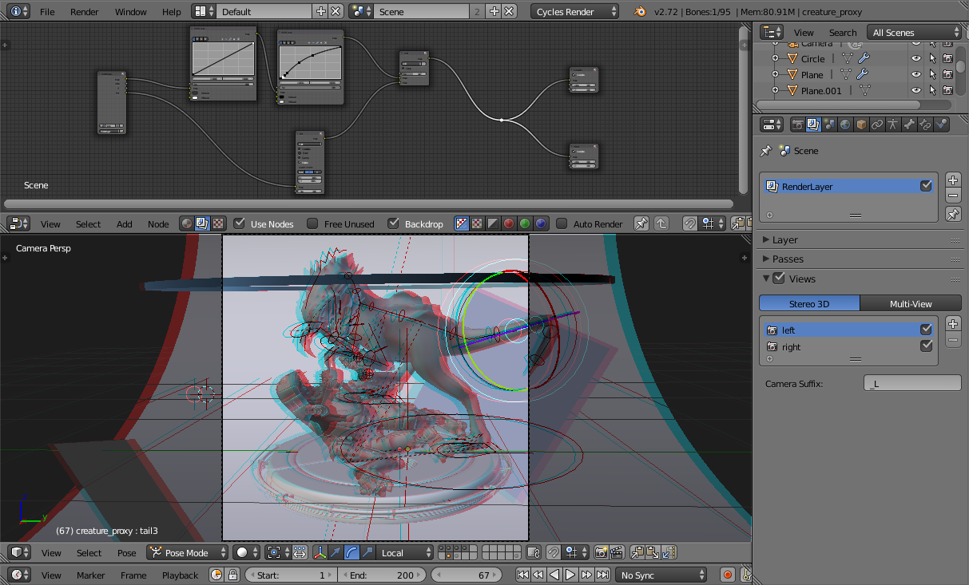
Viewport with 3D visualization

Camera
To tweak the stereo 3d parameters select the camera in the Outliner. In the Camera panel go to the Stereoscopy tab and change the Convergence Distance.
The viewport will respond in real-time to those changes allowing you to preview the current depth value of the scene.
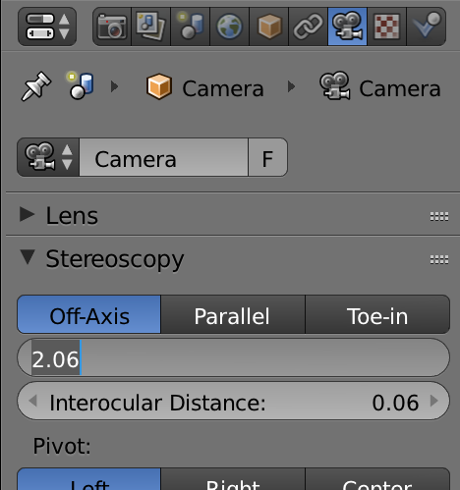
Stereo Convergence Distance

Viewport
Before fine-tuning the camera parameters you can set the convergence plane in the viewport based in your scene depth layout. Go outside the camera view and you will instantly see the convergence plane in front of the camera.
You can toggle this and other display settings in the Stereoscopy tab of the viewport properties panel. In the following image the cameras frustum volumes are also visible.
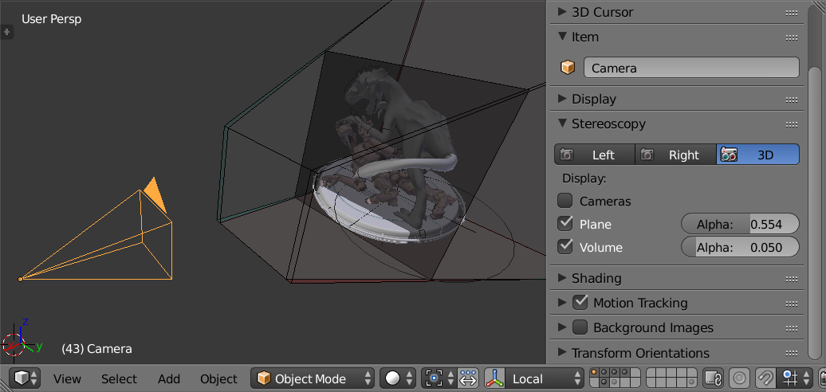
Viewport Plane and Volume Stereo Preview

Stereo 3D Display
If you have a real 3d display at some point you can change the 3D display mode in the Window menu, by calling the Stereo 3D operator. Be aware that some modes require a fullscreen editor to work.
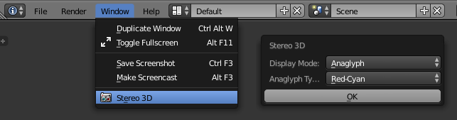
Window Menu, Stereo 3D Operator

OpenGL Preview
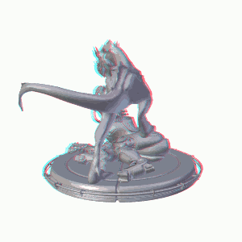
Turn Table OpenGL Rendering Preview
Before rendering your scene you can save an OpenGL preview of the animation for testing in the final display. In the Render Output panel you can chose the output Views Format.
The options include individual files per view, top-bottom, anaglyph among others. Pick the one that fits your display requirements.

Rendering and Image Editor
Once you are happy with the results you can render out the final animation. In the Image Editor you can inspect the individual views and the stereo result.

Image Formats
Your final animation can be saved in more robust formats than the ones used by the OpenGL render preview. In this example we saved as cross-eyed side-by-side stereo 3d.
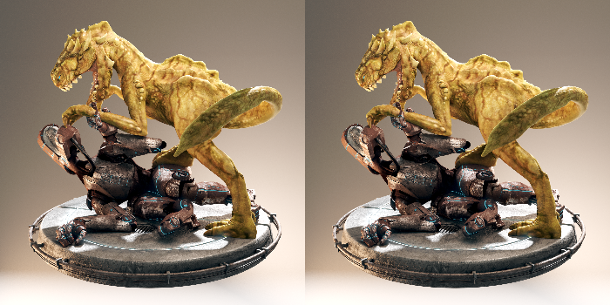
Side by Side Cross-Eye Format

Final Considerations
As this guide showed, there is more to stereo 3d rendering than just generate two images. The earlier the stereo pipeline is considered the smoother it will get. The following sections are a more in-depth view of the individual components we visited in the workflow.

Window Stereo 3D Display
An essential component of the Stereoscopy pipeline is the ability to display the stereo image in a proper display. Bforartists supports from high-end 3D displays to simple red-cyan glasses. On top of that you can set a different display mode for each window.
The display mode can be changed via the Window menu or if you create your own shortcuts for the wm.set_stereo_3d operator.
Window Menu, Stereo 3D Operator

Display Mode
Anaglyph
Render two differently filtered colored images for each eye. Anaglyph glasses are required. We support Red-Cyan, Green-Magenta and Yellow-Blue glasses.
Interlace
Render two images for each eye into one interlaced image. A 3D-ready monitor is required. We support Row, Column and Checkerboard Interleaved. An option to Swap Left/Right helps to adjust the image for the screen. This method works better in fullscreen.
Time Sequential
Renders alternate eyes. This method is also known as Page Flip. This requires the graphic card to support Quad Buffer and it only works in fullscreen.
Side-by-Side
Render images for left and right eye side-by-side. There is an option to support Cross-Eye glasses. It works only in fullscreen, and it should be used with the Full Editor operator.
Top-Bottom
Render images for left and right eye one above another. It works only in fullscreen, and it should be used with the Full Editor operator.
Note
Full Screen Stereo 3D Modes
If you have a 3D display most of the time you will use it to see in stereo 3D you will have to go to the fullscreen mode. In fact some modes will only work in the full window mode that hides most of the user interface from the work area. In this case it is recommended to work with two monitors, using the 3D screen for visualizing the stereo result while the other screen can be used for the regular Bforartists work.

Stereo 3D Camera
When using the Stereo 3D scene view setup a stereo pair is created on-the-fly and used for rendering and previsualization. For all the purposes this works as two cameras that share most parameters (focal length, clipping, ...). The stereo pair, however, is offsetted, and can have unique rotation and shift between itself.
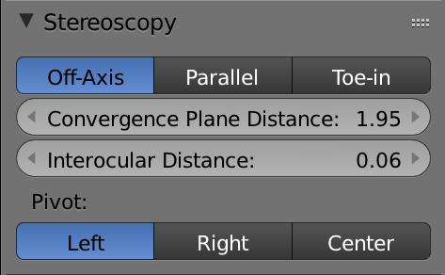
Stereo 3D Camera Settings
Interocular Distance
Set the distance between the camera pair. Although the convergence of a stereo pair can be changed in post-production, different interocular distances will produce different results due to the parts of the scene being occluded from each point of view.
Convergence Plane Distance
The converge point for the stereo cameras. This is often the distance between a projector and the projection screen. You can visualize this in the 3D Viewport.

Convergence Mode
Off-Axis
The stereo camera pair is separated by the interocular distance, and shifted inwards so it converges in the convergence plane. This is the ideal format since it is the one closest to how the human vision works.
Parallel
This method produces two parallel cameras that do not converge. Since this method needs to be manually converged it can’t be used for viewing. This method is common when combining real footage with rendered elements.
Toe-in
A less common approach is to rotate the cameras instead of shifting their frustum. The Toe-in method is rarely used in modern 3D productions.
Pivot
The stereo pair can be constructed around the active camera with a new camera built for each eye (Center Pivot) or using the existing camera and creating (Left or Right). The latter is what is used when only one eye needs to be rendered for an existing mono 2D project.

Viewport Stereo 3D
When you enable ‘Views’ in the Render Layer panel a new are is available in the 3D Viewport properties panel. In this panel you can pick whether to see the stereo 3d in the viewport, or which camera to see. It also allow you to see the Cameras, the Plane and the Volume of the stereo cameras.
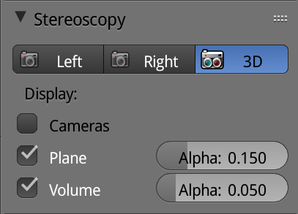
Viewport Stereo 3D Settings
Cameras
When working with the Stereo 3D views setup you can inspect what each individual generated camera is looking or the combined result of them. In the Multi-View mode you can see the combined result of the left and right cameras (when available) or the current selected camera.
Plane
The convergence plane represents the screen as it is perceived by the audience. Visualizing it in the 3D Viewport allows you to layout your scene based on your depth script outside the camera view.
Volume
The intersection of the stereo cameras frustums helps planning the show by avoiding elements being visible by only one camera. The volume is defined by the cameras start and end clipping distances. The areas that are in the frustum of one camera only are known as retinal rivalry areas. They are tolerated in the negative space (the region from the convergence plane into the image) but are to be avoided at all costs in the positive space (the area from the convergence plane to the camera).
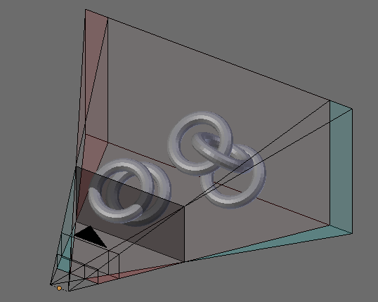
Viewport 3D: Convergence Plane and Volume Display

Multi-View and Stereo 3D Image I/O
Multi-View and Stereo 3D
Multi-View images can be saved in special formats according to the production requirements. By default the system saves each view as an individual file, thus generating as many files as views to be rendered. In stereo 3d productions, for the final deployment or even intermediary previews it’s convenient to save stereo 3d images, that are ready to use with 3D displays or simple anaglyph glasses. The formats supported match the display modes available for the window.
Lossy-Formats
Some stereo 3D formats represent a considerable loss of data. For example, the Anaglyph format will cap out entire color channels from the original image. The Top-Bottom compressed will discard half of your vertical resolution data. The Interlace will mash your data considerably. Once you export in those formats, you can still import the image back in Bforartists, for it to be treated as Stereo 3D. You will need to match the window stereo 3d display mode to the image stereo 3d format though.
Lossless Formats
Some formats will preserve the original data, leading to no problems on exporting and importing the files back in Bforartists. The Individual option will produce separate images that (if saved in a lossless encoding such as PNG or OpenEXR) can be loaded back in production with no loss of data. For the Stereo 3D formats the only lossless options are Top-Bottom and Side-by-Side without the Squeezed Frame option.
Multi-View Openexr
Another option is to use Multi-View OpenEXR files. This format can save multiple views in a single file and is backward compatible with old OpenEXR viewers (you see only one view though). Multi-View native support is only available to OpenEXR.

Image Editor
View Menu
After you render your scene with Stereo 3D you will be able to see the rendered result in the combined stereo 3d or to inspect the individual views. This works for Viewer nodes, render results or opened images.
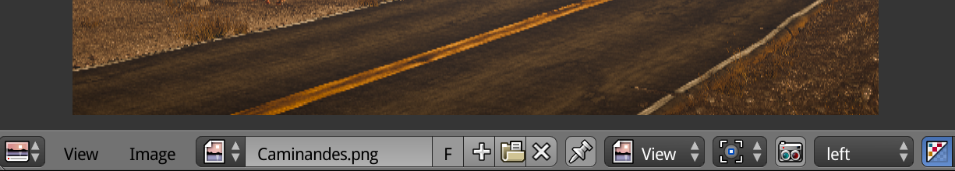
Stereo 3D and View menu
Views Format
When you drag and drop an image into the Image Editor, Bforartists will open it as a individual images at first. If your image was saved with one of the Stereo 3D formats you can change how Bforartists should interpret the image by switching the mode to Stereo 3D, turning on Use Multi-View and picking the corresponding stereo method.
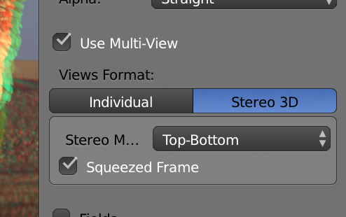
Views Formats and Stereo 3D

Compositor
The compositor works smoothly with Multi-View. The compositing of a view is completed before the remaining views start to be composited. The pipeline is the same as the single-view workflow, with the difference that you can use Image, Movies or Image Sequences in any of the supported Multi-View formats.
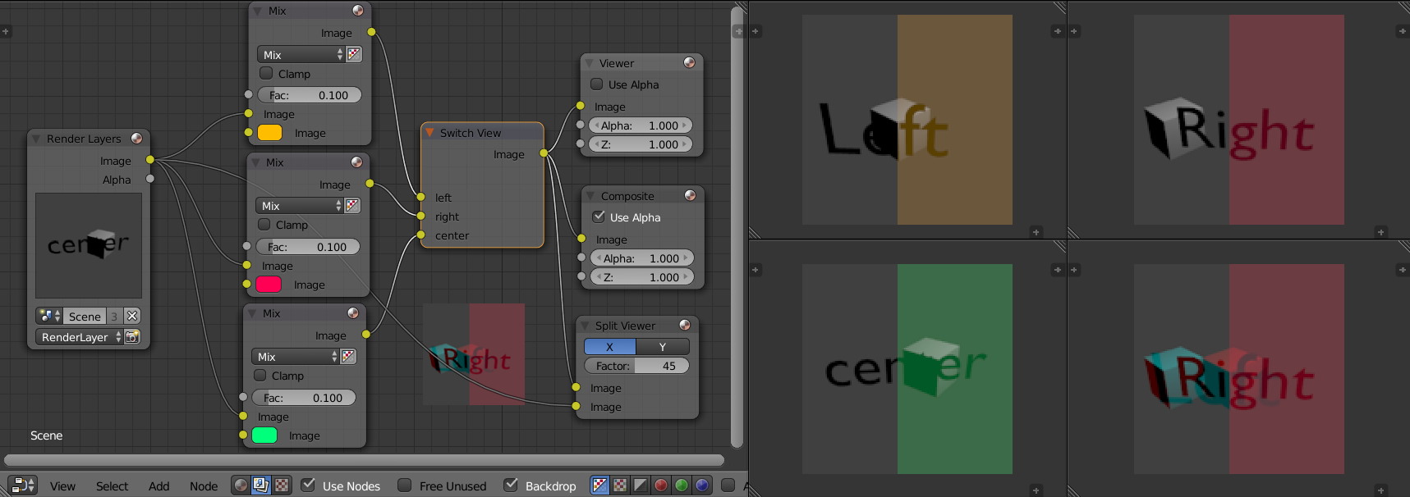
Compositor, Backdrop and Split Viewer Node
The views to render are defined in the current scene views, in a similar way as you define the composite output resolution in the current scene render panel, regardless of the Image nodes resolutions or RenderLayers from different scenes.
Note
Single-View Images
If the image from an Image Node does not have the view you are trying to render, the image will be treated as a single-view image.
Switch View Node
If you need to treat the views separately you can use the Switch View node to combine the views before an output node.
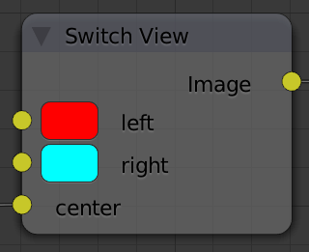
Switch View Node
Performance
By default when compositing and rendering from the user interface all views are rendered and then composited. During test iterations you can disable all but one view from the Scene Views panel, and re-enable it after you get the final look.

